Summary from James’ visit

**A: how to reason about external calls and how to reason about protection in the open world,**

Here the call of an external function. Note that I changed the notation for “y is protected from x by module M” to be

[ext-call]

-------------------------------------------------------------------------------------------------------------------------------------------------------------------------------------------------------------------------------------------------

M ⊢ { A ∧ Ext x ∧ y⧘x } x.m() { Ret(A ∧ Inside(y), HSM) }

In the above, HSM is the holistic specification of M. And we define “y is protected from x by module M” as below

M, 𝜎 ⊨ y⧘x ≜ ∀n,f1,…fn. [ 𝜎(x.f1…fn) = y ⟹ ∃ k<n. 𝜎(x.f1…fk)∈ M ]

Note that the above definition does not preclude tat the path once it went through M, can go outside again. Here it is possible that j>k ∧ 𝜎(x.f1…fj) ∉ M.

And we need some HL rules for the preservation of y⧘x. For example, something like

[prot-1]

-------------------------------------------------------------------------------------------------------------------------------------------------------------------------------------------------------------------------------------------------

M ⊢ { x≠u ∧ y⧘x } u=v { y⧘x }

[prot-2]

-------------------------------------------------------------------------------------------------------------------------------------------------------------------------------------------------------------------------------------------------

M ⊢ { u⧘x ∧ y⧘x } u=v.f { y⧘x }

**B: Obtaining holistic specs of more than one module**

**Lack of monotonicity**

Here some implications which do not hold in general (btw, check in how far they would hold in the closed world)

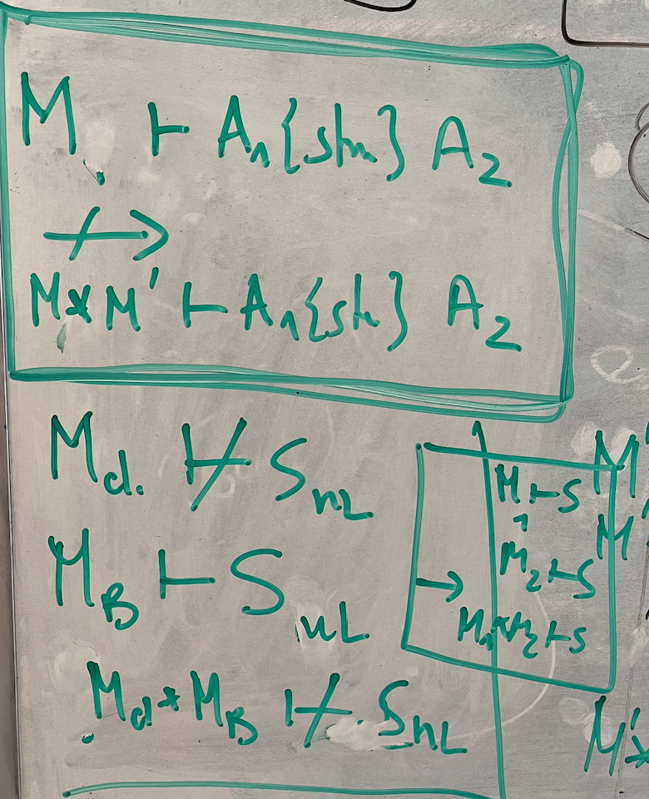

For example:

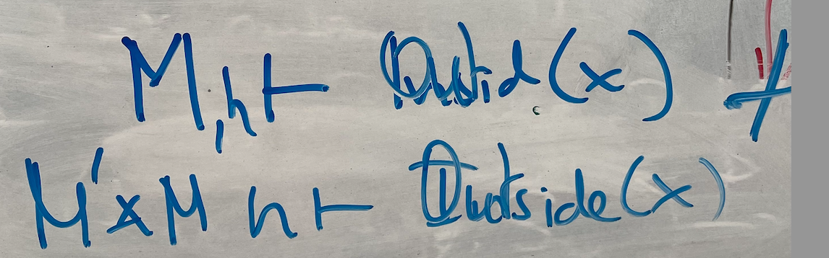

And similarly, the following implication does not hold, eg “Accountant” gives a counter-example

|  |  |
| --- | --- |
|  | Here the code of accountant   |

However, some assertions are “stable”, and then, more implications hold

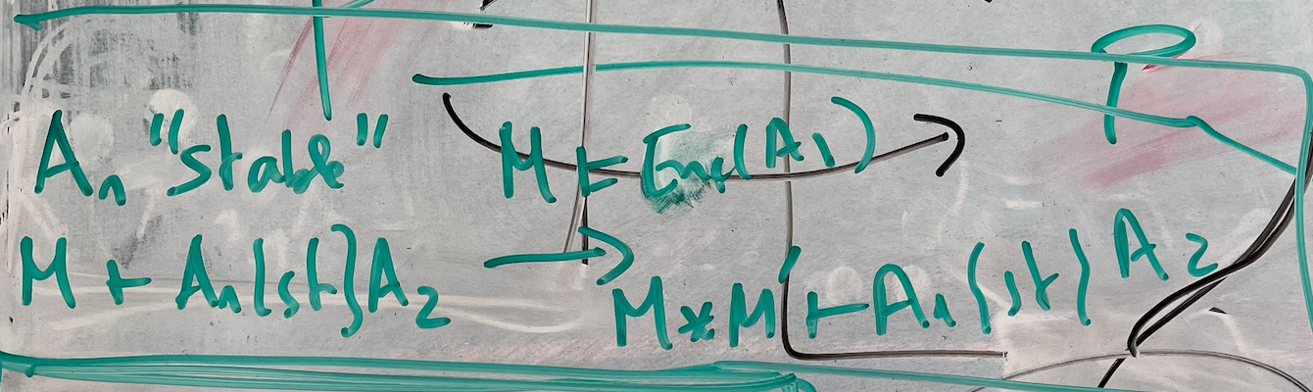

**How do we combine modules into larger ones?**

When we combine modules, we should distinguish between

1. M1[M2] M1 encapsulates M2, and M2 is not visible outside M1
2. M1 || M2 M1 and M2 are not aware of each other,  
    and are both visible to outside
3. M1[M2] || M2  
    M1 uses M2, and they are both visible to outside
4. M1[M2] || M2[M1]  
    M1 and M2 use each ither, and are both visible to outside

**Three avenues to obtain holistic specs from several modules**

|  |  |
| --- | --- |
|  | P is dedicated, ie we have M[P]  Q::= P | M  Q.tr : classical triples for Q  Q.HS : Holistic Spec Q  Black arrows:   as we did in OOPSLA’23  Blue Arrow (new)  Combine Holistic Specs  Red Arrow (new)  Combine Code and HS |

An Example of the “red avenue” from above. Here, printers keep authorization tokens, and only print if the call print(k) passes a k which is one of the authorization tokens. In that case the call print)k) returns true.  
  
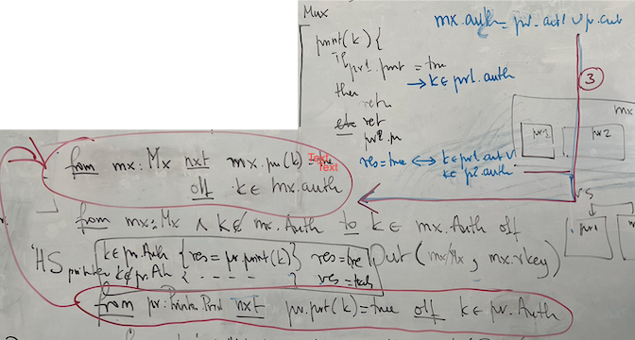

An Example of the “Blue Avenue” from above

|  |
| --- |
| Here the general rule   |
| Here its application  A white board with writing on it  Description automatically generated with medium confidence  The combined holistic spec should be  A whiteboard with writing on it  Description automatically generated with medium confidence  Or perhaps should be  Text, letter  Description automatically generated |

**Example: Printer, Printer Multiplexer and Bank**

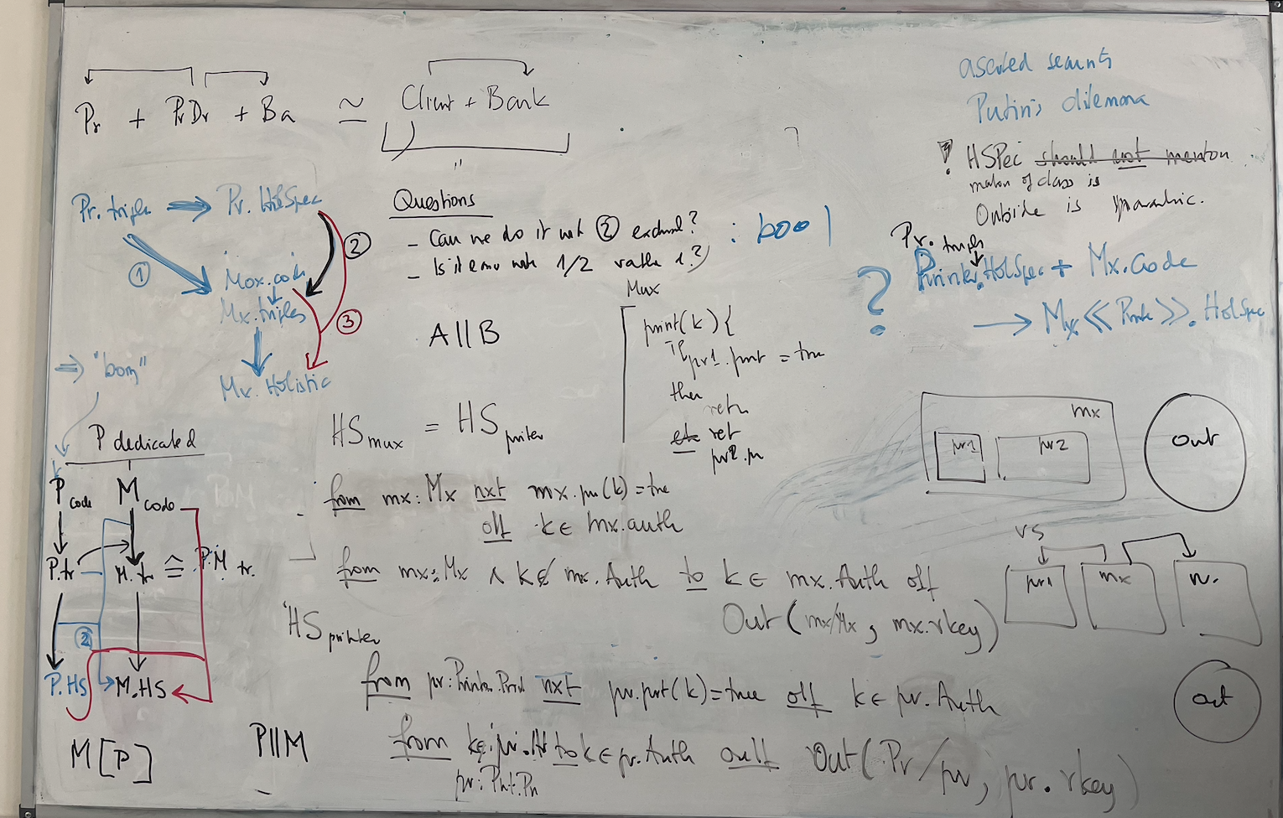

**Things that I have not yet fully “deciphered”**

I think that G stands for obeys, P for pays, but B?

